Android Core – Data Downloader – Customize Layouts

In order to customize the installer's layouts, add your modifications in your project's res folder and place the in res/drawable and res/values.

There are several ways of customizing the data downloader's layouts:

Override the graphic elements that you want to customize.
- Place the background image you want to use in res/drawable and rename it to: data_downloader_background.9.png
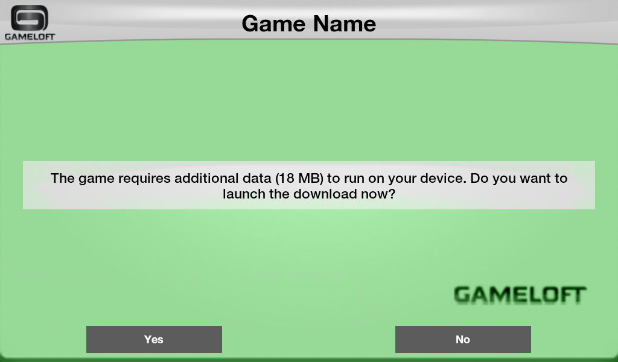
- Place the buttons images you want to use in res/drawable:
  - for the normal state of the button, rename it to: data_downloader_button_normal.9.png
  - for the pressed state of the button, rename it to: data_downloader_button_pressed.9.png
  - for the focused state of the button, rename it to: data_downloader_button_focus.9.png
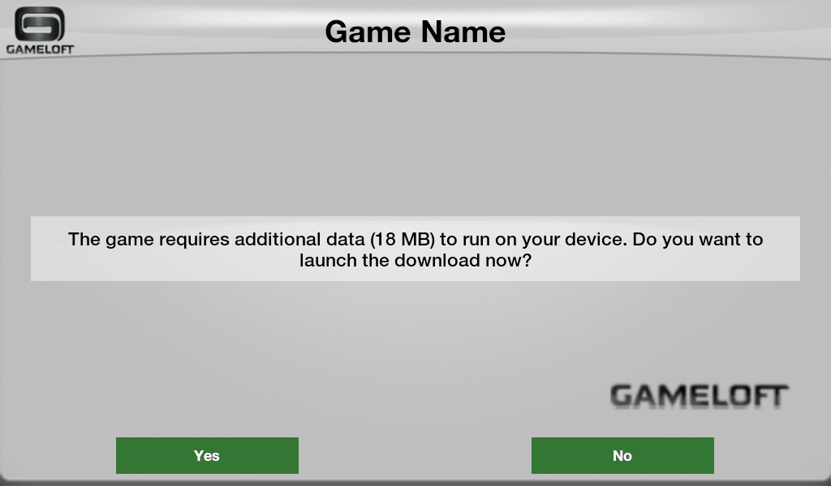
- Place the title background bar your want to use in res/drawable and rename it to data_downloader_title_background.9.png
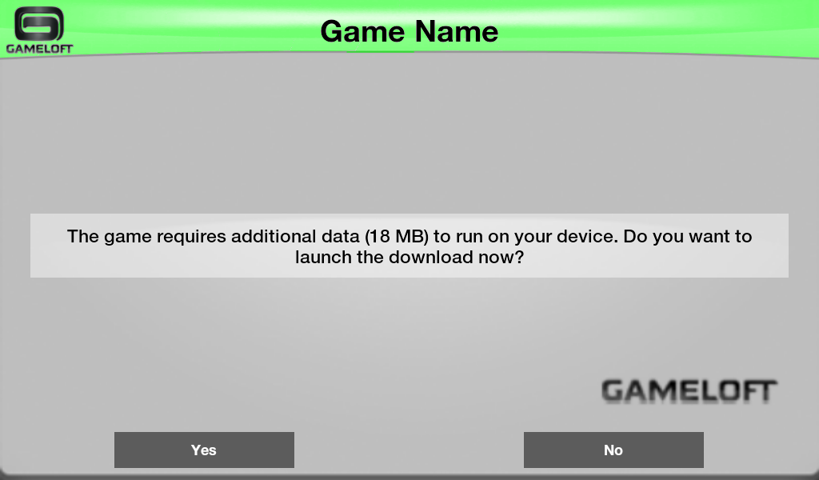
- Place the progress bar images you want to use in res/drawable:
  - the foreground part of the progress bar has to be renamed to progress_foreground.png
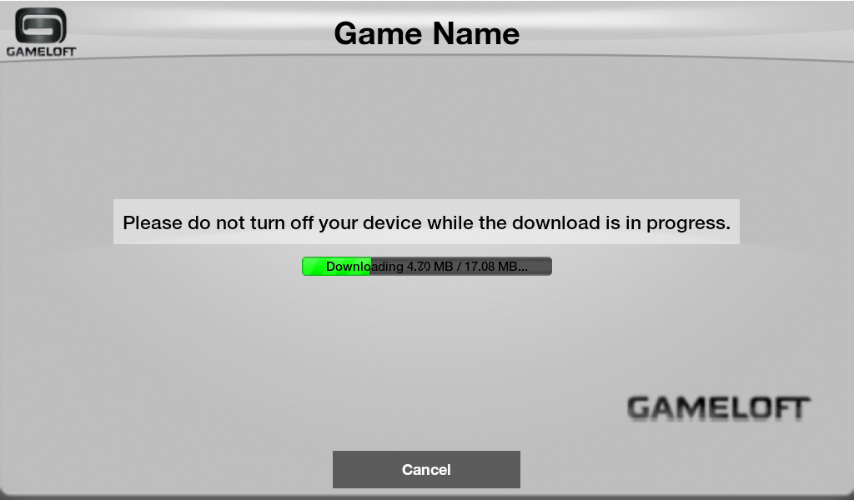
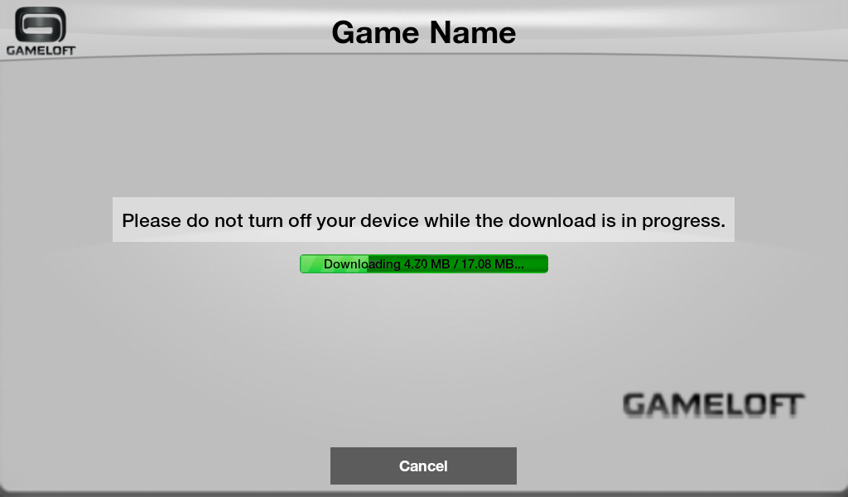
  - the background part of the progress bar has to be renamed to progress_background.png

- Place the image of the splash screen you want to use in res/drawable and rename it to data_downloader_splash_logo.png

- Note: Read the article about Draw-9-Patch on how to customize scalable drawable images. You can also have different images for different screen sizes. Read more about this on Supporting Multiple Screens. Also if you need different resources for different locales read the article Using Resources for Localization.

Override the configuration file
Override the configuration file found in the package under res_apk/installer/res/values/data_downloader_dimensions.xml by copying it to your project's res/values without changing it name. In this file you will be able to modify the following values:
- For the title bar:
  - Height: data_downloader_title_height
  - Text size: data_downloader_title_text_size
  - Text color: data_downloader_title_text_color
  - Logo padding top: data_downloader_title_logo_paddingTop
  - Logo padding bottom: data_downloader_title_logo_paddingBottom
  - Logo padding left: data_downloader_title_logo_paddingLeft
  - Logo padding right: data_downloader_title_logo_paddingRight
  - Text style: data_downloader_title_text_default_style → textStyle (normal, bold, italic)
  - Text typeface: data_downloader_title_text_default_style → typeface (normal, sans, serif, monospace)
- For the buttons:
  - Height: data_downloader_button_height
  - Width: data_downloader_button_width
  - Text size: data_downloader_button_text_size
  - Text color: data_downloader_button_text_color
  - Button padding left: data_downloader_button_padding_left
  - Button padding right: data_downloader_button_padding_right
  - Button padding top: data_downloader_button_padding_top
  - Button padding bottom: data_downloader_button_padding_bottom
  - Text style: data_downloader_button_text_default_style → textStyle (normal, bold, italic)
  - Text typeface: data_downloader_button_text_default_style → typeface (normal, sans, serif, monospace)
- For the main text:
  - Text size: data_downloader_button_text_size
  - Text color: data_downloader_button_text_color
  - Text View padding left: data_downloader_main_text_padding_left
  - Text View padding right: data_downloader_main_text_padding_right
  - Text View padding top: data_downloader_main_text_padding_top
  - Text View padding bottom: data_downloader_main_text_padding_bottom
  - Background image or color: data_downloader_main_text_image_color → background (ex: #AARRGGBB or @drawable/image_name)
  - Text style: data_downloader_main_text_image_color → textStyle (normal, bold, italic)
  - Text typeface: data_downloader_main_text_image_color → typeface (normal, sans, serif, monospace)
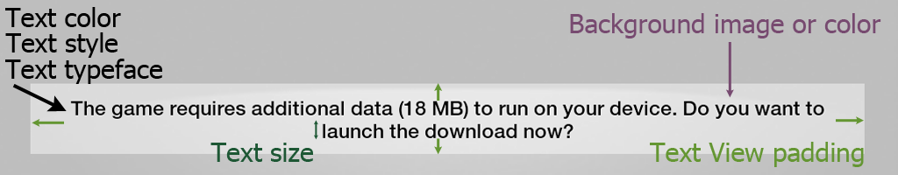
- For the progress bar:
  - Height: data_downloader_horizontal_progessbar_height
  - Width: data_downloader_horizontal_progessbar_width
  - Text size: data_downloader_progress_text_size
  - Text color: data_downloader_progress_text_color
  - Text style: data_downloader_progress_text_extra_style → textStyle (normal, bold, italic)
  - Text typeface: data_downloader_progress_text_extra_style → typeface (normal, sans, serif, monospace)
  - Top padding: data_downloader_progress_bar_padding_top
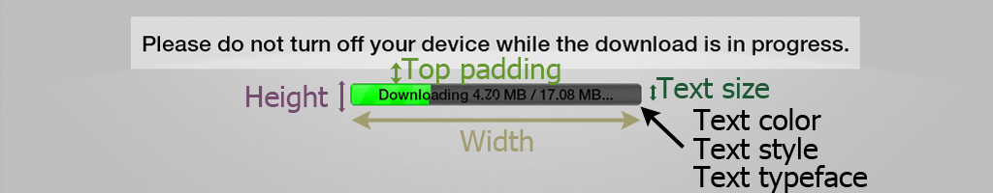
- For the splash image:
  - Background color: gi_gameloft_logo_background_color
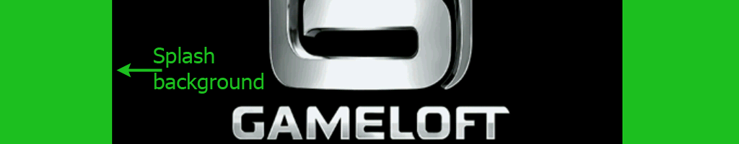
- The font used for all the elements:
  - Name: data_downloader_custom_font_name (ex: font.ttf)
  - Place the font in your project's assets folder
  - The font must be in TTF format

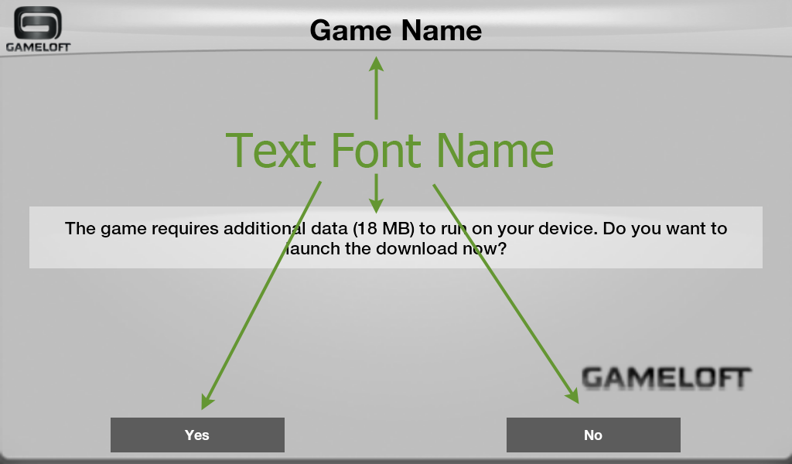
Override the style file
If you want to modify more using the same elements, you can do this by overriding the data_downloader_layout_values.xml. It can be found in res_apk/installer/res/values/. Copy it and place it in your project's res/values with the same name. In this file you can modify the styles of each element of the layouts used by the data downloader, formally known as installer. Each layout (the one with the buttons, the one with a progress bar and the one with a horizontal progress bar) is composed of three main parts, like in the image:
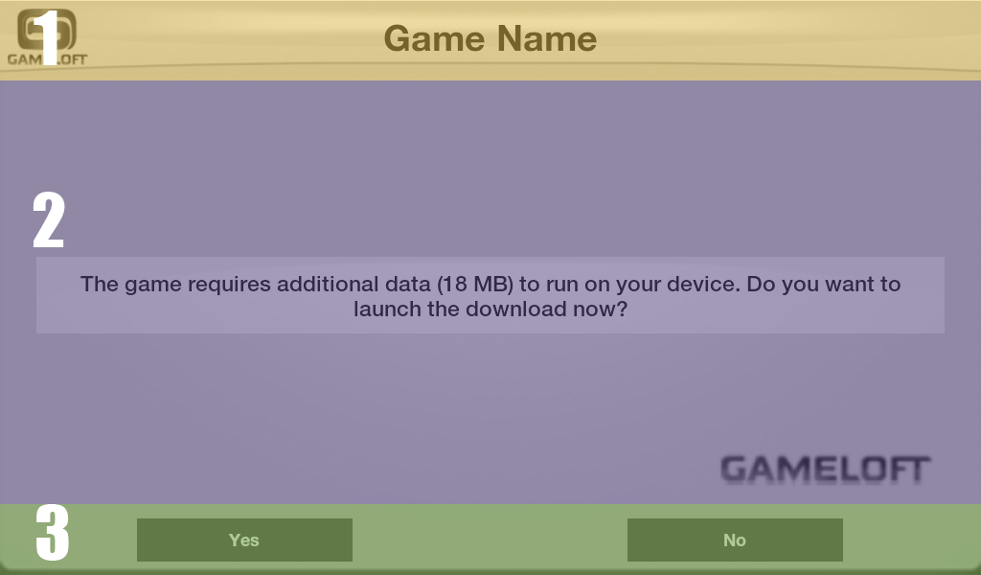
The majority of the elements are inside RelativeLayouts so you can easily modify the elements location by modifying or adding values for:
- android:layout_centerVertical
- android:layout_centerHorizontal
- android:layout_alignParentLeft
- android:layout_alignParentRight
- android:layout_alignParentTop
- android:layout_alignParentBottom
- android:layout_below
- android:layout_above
Note: To have a better view of how you should apply the changes check the RelativeLayout page on Android Developers and Styles and Themes

Override the layouts
The last way to have a fully custom layouts system for the data downloader is to override the following files in /res/layouts:
- data_downloader_progressbar_layout.xml: layout with 3 buttons and a indefinite progress bar
You must keep the ids for the following elements:
  - data_downloader_main_text
  - data_downloader_progress_bar
  - data_downloader_yes
  - data_downloader_no
  - data_downloader_cancel
- data_downloader_linear_progressbar_layout.xml: layout with 3 buttons, a horizontal progress bar and a webview
You must keep the ids for the following elements:
  - data_downloader_main_text
  - data_downloader_linear_progress_bar
  - data_downloader_webview
  - data_downloader_yes
  - data_downloader_no
  - data_downloader_cancel
- data_downloader_buttons_layout.xml: the message layout with 3 buttons
You must keep the ids for the following elements:
  - data_downloader_main_text
  - data_downloader_yes
  - data_downloader_no
  - data_downloader_cancel
- gi_layout_download_toast_message.xml: the toast message layout
You must keep the ids for the following elements:
  - data_downloader_toast_title
  - data_downloader_toast_message
- gi_layout_logo.xml: the splash screen layout
- title_layout.xml: the title bar layout

Contact
Christian Alexandru Tatu
christianalexandru.tatu@gameloft.com

